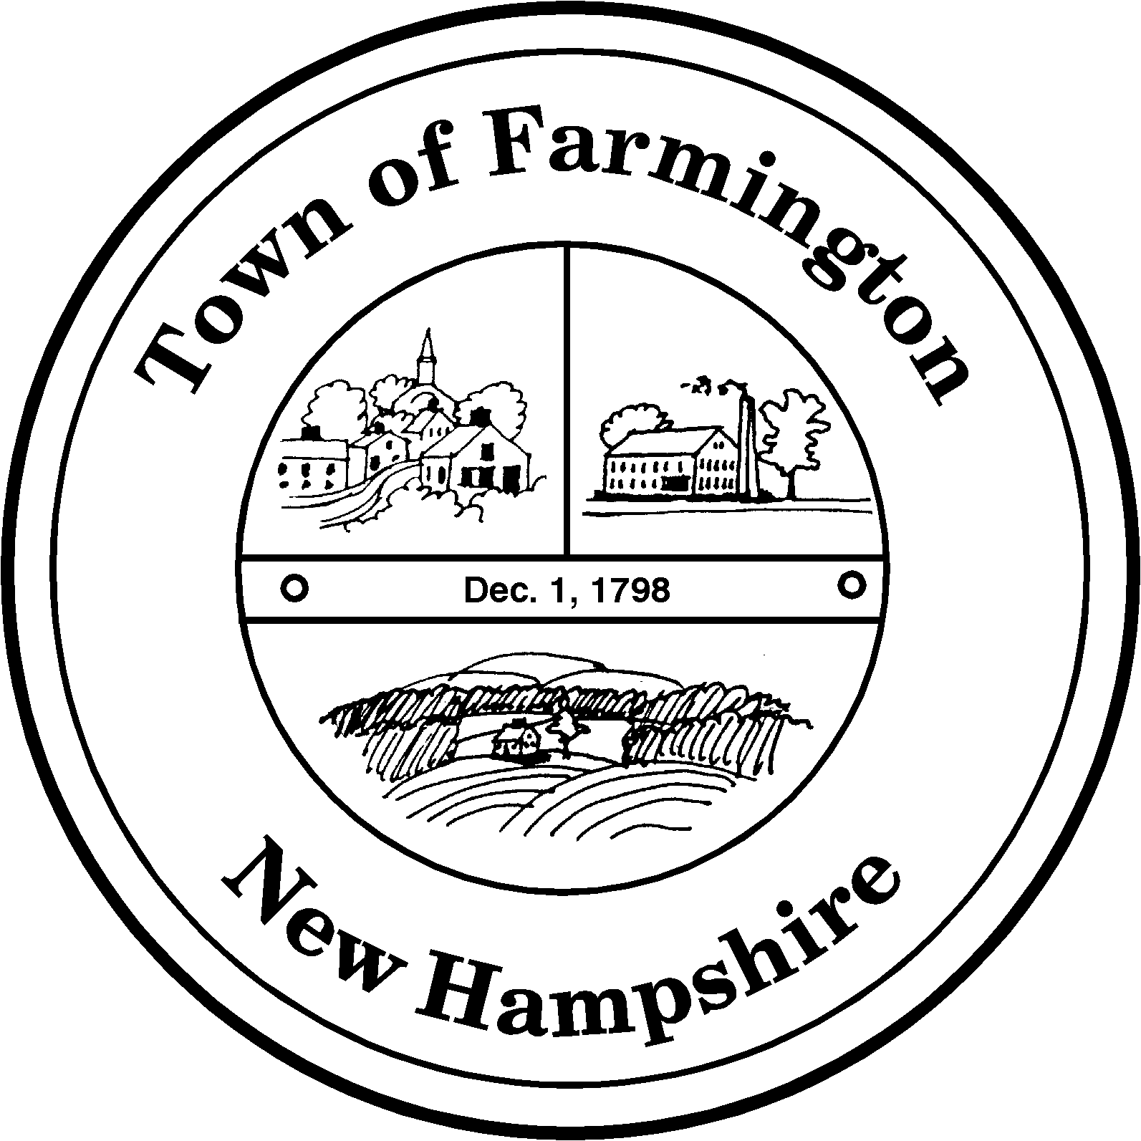
Town of Farmington
Planning and Community Development
356 Main Street
Farmington, NH 03835
Phone: (603) 755-2774
A Bicentennial Community
1798 - 1998

PLANNING BOARD MEETING

Tuesday – May 21, 2013

356 Main Street - Farmington, NH

AGENDA - 6:00 pm

BUSINESS BEFORE THE BOARD:

- Pledge of Allegiance
- Review and approve Meeting Minutes of May 7, 2013 and May 14, 2013
- Request from NH-DOT for comments on a driveway permit application
- Any other business to come before the Board

PUBLIC HEARING - 6:30 pm

NEW CASES:

Application for Minor Subdivision by: Hattie G. Hussey, applicant/property owner through Geometres Blue Hills, LLC as Agent (Tax Map R38, Lot 9) for property located at 797 Ten Rod Road. The applicant proposes to create two lots from the existing 59.35 acre parcel resulting in lots of 22.31+/- acres and 36.97+/- acres with an existing residence. The parcel is located in the Agricultural Residential (AR) Zoning District.

Application for Major Site Plan Review by: Powerhouse Machine, LLC (Tax Map R03 Lot 17-1): To allow the construction of a laydown area, a 12,000 sq. ft. cold storage building with underground electric service, and related access way. The parcel is located at 23 Commerce Parkway in the Industrial Business (IB) Zoning District.

Application for Minor Subdivision by: Jean G. Merrill, applicant/property owner (Tax Map R32, Lot 15) through David W. Vincent Land Surveying Services as Agent for property located at 149 Main Street. The applicant proposes to create two lots from the existing 24 acre parcel resulting in lots of 23 acres and 1 acre to include an existing residence and accessory structures. The parcel is located in the Suburban Residential (SR) Zoning District and the Urban Residential (UR) Zoning District.

Paul Parker, Chairman

Farmington Planning Board

